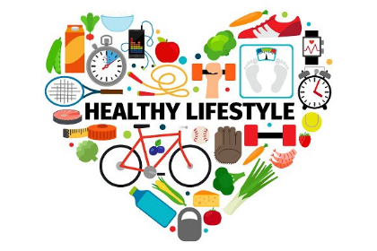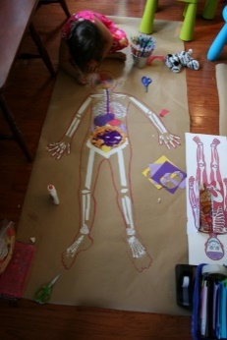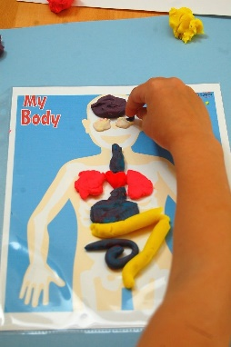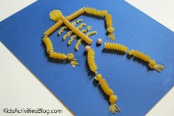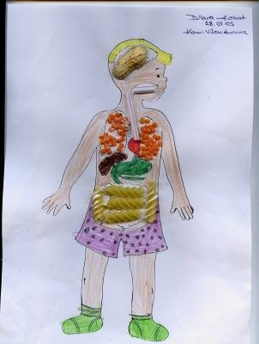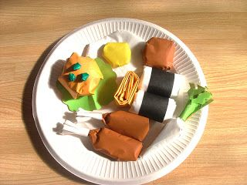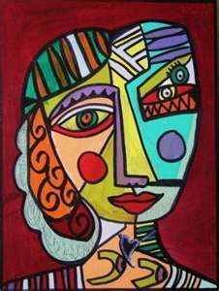

**CLEVER CONVERSATION**

What makes you you?

What do you need to be happy?

What do you think is the best age to be and why?

Is it possible to have a perfect friend?

Should people care more about doing the right thing or doing things right?

Could advertising during children’s TV be the reason we like unhealthy foods?

**Are you what you eat?**

**AMAZING ARTS**

Can you create a model/poster of the human body and the organs we have?

Label and describe some of the organs that you know

**ALL AROUND THE WORLD**

Can you name any foods that you like from around the world?

See if you can design and make your favorite dish. Cook draw, craft however you like!

**AMAZING ARTS**

Can you create your very own Pablo Picasso art?

Can you use different media to help you?

For example; magazines,

newspapers, paint, chalk,

crayon, pencils, pens, fabric,

tissue, paper, etc.

How many different Medias

can you use?

**WONDERFUL WRITING**

1. Can you write a persuasive letter to Mrs Stalham urging her to promote healthy eating, healthy living and exercise to the children of Winter Gardens?

**Use these points to help you:**

-The importance of healthy eating

-The importance of exercise

-The importance of a healthy mindset

-What makes a healthy diet?

2. Can you create a poem about your emotions using the Zones of regulation?

**For example:**

What makes you happy?

What makes you sad?

What makes you nervous/worry?

What makes you angry?

**SUPER SCIENTISTS**

Can you investigate the importance of exercise on your body?

Keep a fitness diary of your heart rate.

Can you record you heart rate at the beginning of exercise, straight after exercise and 20 minutes after exercise.

What do you notice about the speed?

**MARVELOUS MUSIC**

What music can you make just using your body as an instrument?

Can you make loud sounds?

Can you make quiet sounds?

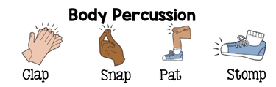

**RELAXING READING**

Can you find any reading materials (books, leaflets, comics) about the human body?

**Spring 2**

This homework is optional. Please choose an activity/activities if you would like to. We would love to see what you have done so please bring it in to share with your class teacher!